Learner Pack
Recommended
SCIENCE LESSONS
(Choose your task from below)
R  1  2 | What is your favourite animal?  Draw a picture of you and your favourite animal.  What would your animal need to be happy? | Go through your toys and sort them into 2 groups.  Living Non-living  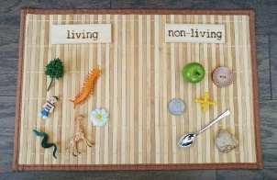 | What can you see in the wild? Can you spot any living creatures around your house?  Draw and/or write all the creatures you can see. | Make a list of all the ways that you and your family are using water at home.  Talk about what would happen if we ran out.
3  4 | The sun is so important.  Think about what would happen if went away. Write a short story about ‘The day the sun disappeared’ | Design a poster showing all the animals only found in Australia.  Research which plants are also only found in Australia, add them to your poster | Go for a walk; create a list of living and non-living things you see on your adventure. Answer these: Does it eat? Does it grow? Does it move? Does it reproduce? Is it a living thing? | Using a sundial, track the suns movement throughout the day and trace around the shadow at 10, 12, 2, 4 and 6 o’clock.  (Appendix 1)
5  6 | Design a poster showing the different animals in a habitat of your choice.  Habitat ideas:  Rainforest, ocean, river, wetlands/swamp, desert etc. | Using materials at home create a model habitat.  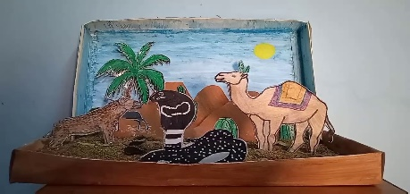 | After following this link : https://www.mobileed  productions.com/blog/how-to-make-a-water-cycle-in-a-bag  Make your own water cycle | Create a volcano at home with your family.  (Appendix 2)

During these times it is important to have a bit of fun! Check out this video that explores the incredibly talented and wild Youtuber; Josephs Machines - https://www.youtube.com/watch?v=iemItSAT9Ew&ab_channel=Quartz
Joseph creates wonderful machines based on the American cartoonist and artist, Rube Goldberg. Mr. Goldberg was known for his wacky drawings of elaborate contraptions that complete simple tasks. Rube was an engineer by trade and used his knowledge of science and working parts to draw these chain reactions.
See if you can make a Rube Goldberg macine at home that completes a simple task!
Rube Goldberg Machines usually solve a problem, but sometimes they are just fun. Decide on what your machine will do. Here are few ideas get you thinking:

Ring a bell
Turn on a light
Shut a door
Feed the dog
Turn on the TV
Pop a balloon
Blow out a candle
Stop an alarm clock

You can use everyday equipment from home as your building materials! Get creative!

Things that roll:
Marbles
Toy cars
Skateboard
Things that build:
Lego
Foil
Cups
Cardboard
Cutlery
Things that move:
Fan
Dominoes
Toilet paper
Rubber bands

